Food
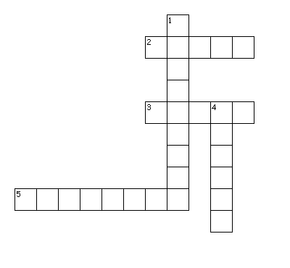
Across
2. traditional Italian food
3. have it at noon
5. green vegetable, contains a lot of water

Down
1. traditional American food
4. helps you wake up in the morning

